CUSTOMER EXPERIENCE STRATEGY OVERVIEW 2019-2022
Appendix 2

Oxford City Council

SUMMARY

At Oxford City Council our customer are at the heart of everything we do.

In a 24-hours a day, 7 days a week connected world, being responsive to customers is a must in any organisation that provides services.

During 2019 Oxford City Council embarked on a series of improvements - enabling it to respond to change, quickly. Our focus is on modernising and enabling the Council to better meet customer needs.

The Customer Experience Strategy brings together the Customer, Digital and Technology strategies and is designed to make a difference in the places where it matters the most, putting customers at the heart of everything we do. It will meet the needs of our customers by giving them:

- Full control about how and when they contact us.
- Access to targeted services they need created by improved data analytics.
- Services that are responsive, modern, accessible and inclusive.

We will do this by adopting a 'Whole Council’ approach, where every part of our organisation will consider how the work they do touches our customers and how to improve our services holistically.

KEY ELEMENTS OF THE CUSTOMER EXPERIENCE STRATEGY

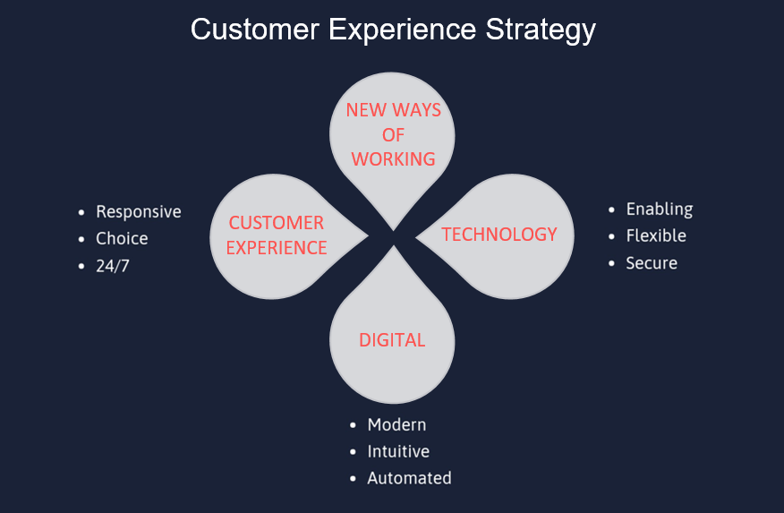

ICT

Our aim is to better equip our colleagues with tools and systems that enable them to respond to customer needs, working flexibly in a secure way.

We will be:
Providing new laptops, desktops and phones to colleagues and members
Replacing our payment systems. Improving our Wi-Fi provision. Upgrading our digital security. Reviewing our legacy systems. Introducing new communication and collaboration tools for colleagues.
CUSTOMER EXPERIENCE

Our aim is to provide holistic customer focused solutions that work across all services. Solutions that are responsive, offer choice in the way customers can contact us and are available 24/7.

We will be investing in:
Mapping the customer journey with input from customers. Customer experience training Management development, specifically how to manage remote teams.
Streamlining our processes. Collaboration tools allowing us to communicate effectively with our customers wherever they are.
DIGITAL

Our aim is to modernise the current systems and processes we use, making them more intuitive, easy to use and automated where needed for both customers and colleagues.

We will be:
- Providing digital skills training for colleagues and customers.
- Redesigning our website.
- Redesigning our intranet.
- Developing new online forms.
- Automating our electronic processes.
- Creating ways to share data with communities to better serve them.
BY DELIVERING THESE KEY ELEMENTS WE WILL

PROVIDE COLLEAGUES THE RIGHT TOOLS FOR THE JOB

WORK EFFICIENTLY AND DELIVER VALUE FOR MONEY

PROVIDE MODERNISED RESPONSIVE SERVICES

CREATE A CULTURE OF 'CUSTOMER FIRST'

INCREASE CUSTOMER CHOICE AND
SATISFACTION

